Scenario 2: Yesterday, users were able to launch the website using public IP. Today user tried to use the same IP but they are unable to browse. [elastic IP]
Yes, it happens, if the instance Is not attached with the elastic IP address.
Even ever server is rebooted/stopped and started the instance public IP will be changed.
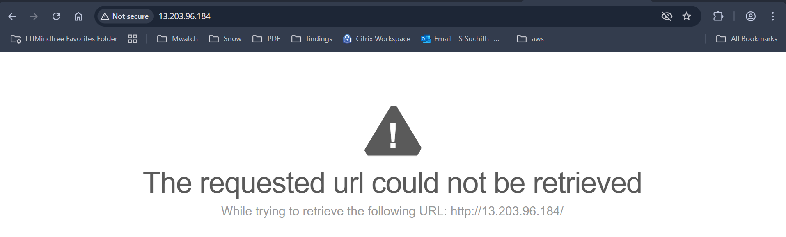
Step 1: we could see that public IP of this instance has been changed.
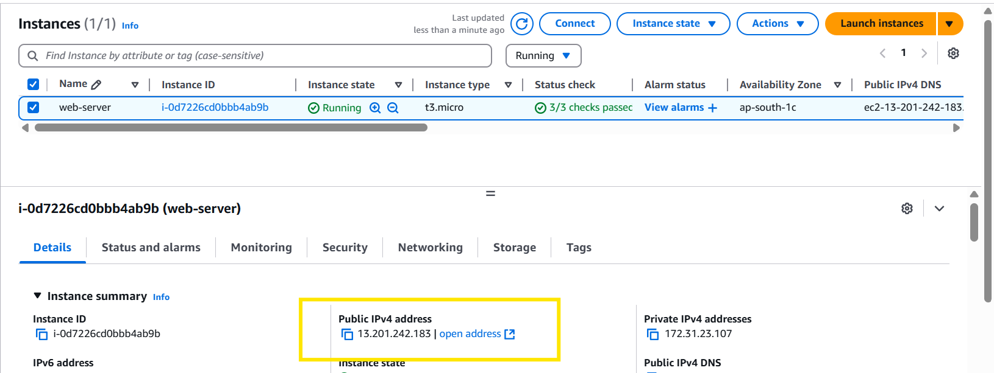

Step 2: lets provide permanent public IP, even though the server is rebooted the IP won’t change.
Step 3: network & security under Elastic Ip > allocate Elastic IP address.
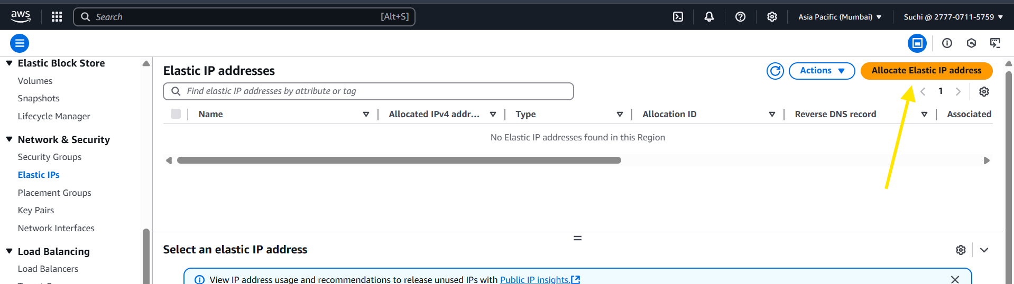
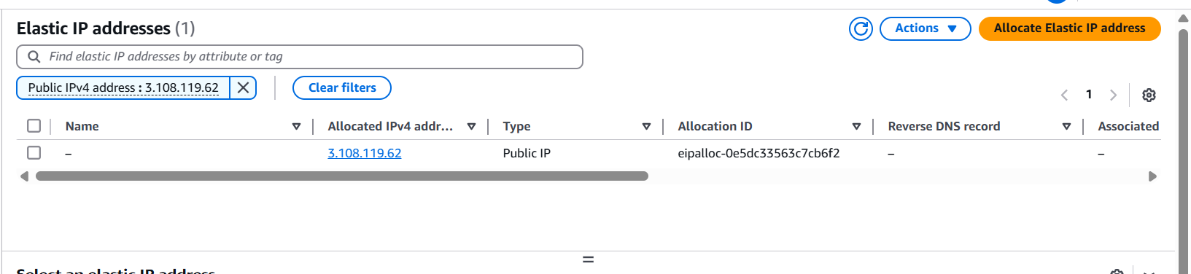
Note:
- Only 5 elastic Ip’s can be used per AWS account. (if needed more we need ask with AWS to increase)
- If it not used not associated with an instance – $0.005 per hour
- If you change the instance more than 100 times per month - $0.10 per remap.
- Free when is use (if attached to a running instance)
Step 4: select the Ip address >action >click on associate
Provide the instance id.
Provide the private Ip address.
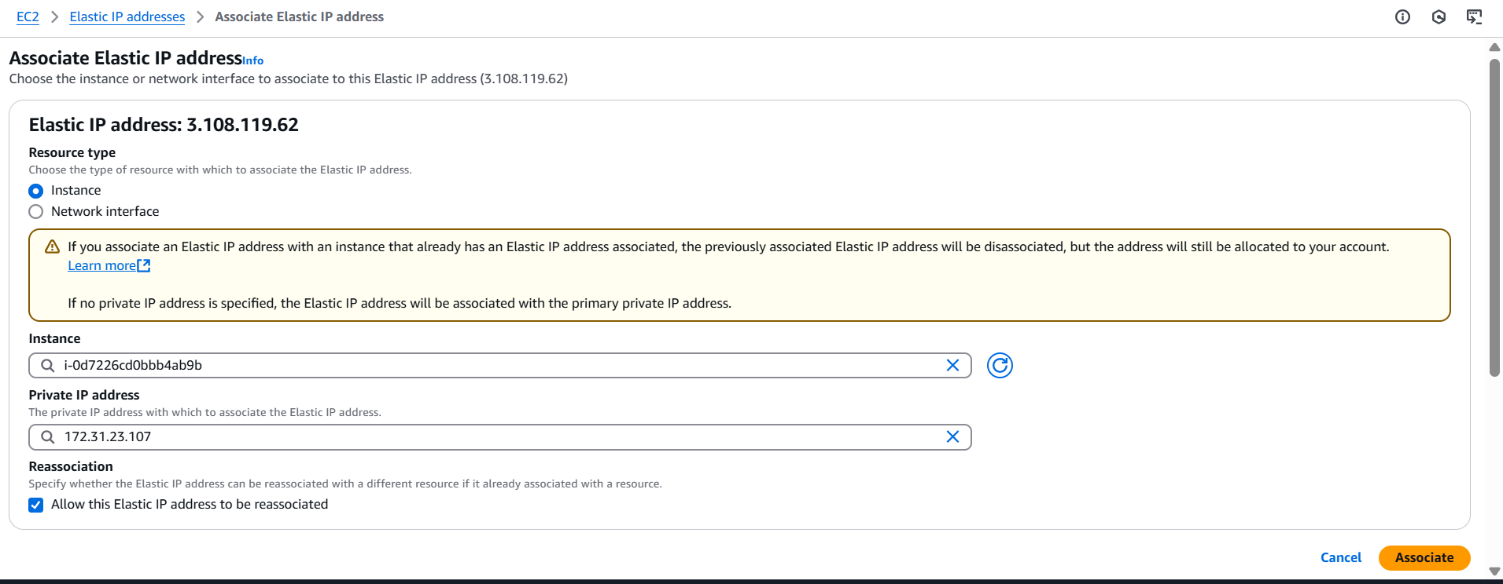
Now we could that existing public Ip as been replaced by the elastic Ip address which we created.
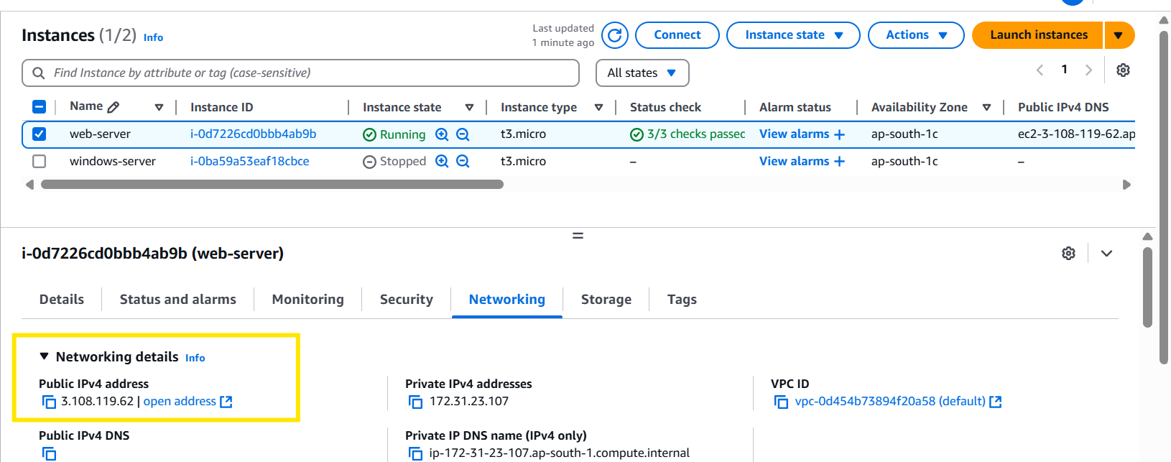

Now we could see that we are able to browse the website the elastic ip.

Step 5: let’s see if I reboot the server will the IP address change.
We could see that public Ip didn’t change.
